Q1 WAP to implement operations shown in the above table 4-1

After getting the above output, read below:

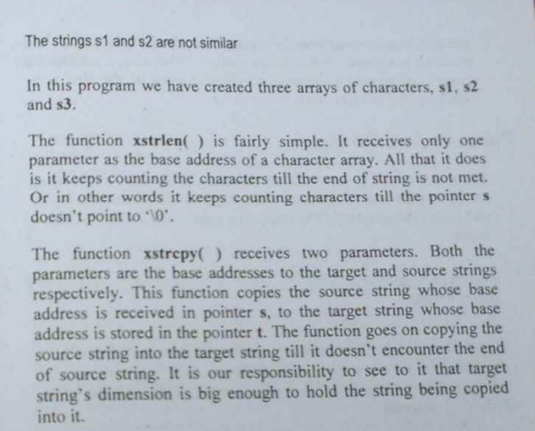

Q2 WAP to type your name and then check your name against a master list to see if you are worthy of entry to the palace.

After getting the output pls read:

Q3 WAP to type your name and then check your name against a master list to see if you are worthy of entry to the palace.—Declare names in an array of pointers.

The Code looks like below:

Read after we get the above output:

Try the below code in your computer:

Write a program to demonstrate the above:

After you get the above output show and confirm your program matches to textbook pg. 96

Implement the above algorithm with two strings  
string 1: NagpurKicit

String 2: Kicit

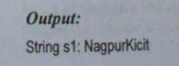

Read below after you got the results: